CATAPULT AND FORT
You need:
- 9 popsticks
- 4 rubberbands
- bottle cap (or cup)
- sticky tape
- item to launch
Put it together:
Stack and band together all but 2 sticks. Band the other 2 sticks as shown. Stick the cap on.
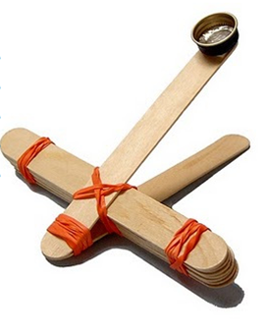
Play:
Try throwing different objects with your catapult. Practice aiming at the target. What objects flyer faster?
You can design your own catapult! Be creative!
Build a Fort
Use the following items to construct a fort of your own design:
- construction paper
- pop sticks
- textas
- sticky tape
- straws
How does it work?
A catapult works because energy can be converted from one type to another and transferred from one object to another.
When you prepare the catapult to launch, you add energy to it. This energy is stored in the launching device as potential, or stored, energy (PE). The catapult you are about to make uses elastic potential energy (PE) stored in a wooden stick as you bend it. When you let go, this stored energy is released, converted into energy of motion (KE) and transferred to the missile (the launched object), which then flies through the air.

