Tower Challenge 1 hour 5+

Australian Curriculum Links
  - Design and Technologies – Foundation to Level 2
Identify how people create familiar designed solutions and consider sustainability to meet personal and local community needs (VCDSTS013)
Explore the characteristics and properties of materials and components that are used to create designed solutions (VCDSTC017)
Explore needs or opportunities for designing, and the technologies needed to realise designed solutions (VCDSCD018)
Visualise, generate, and communicate design ideas through describing, drawing and modelling (VCDSCD019)
Use materials, components, tools, equipment and techniques to produce designed solutions safely (VCDSCD020)
Use personal preferences to evaluate the success of design ideas, processes and solutions including their care for environment (VCDSCD021)
Sequence steps for making designed solutions (VCDSCD022)
  - Mathematics – Measurement and Geometry Year 2
Compare and order several shapes and objects based on length, area, volume and capacity using appropriate uniform informal units (ACMMG037)

Materials
- Index cards or 200gsm board cut into quarters (approx. 15x10cm), at least 30 per group
- Masking tape (1 roll per group)
- Scissors
- Rulers or strips of card 25cm long to measure height of tower

Introduction
We are all going to be engineers today. Did you know that? Isn’t it exciting?
Wait, what’s an engineer? (take suggestions from audience).
An engineer is someone who designs & builds things to solve a problem.
There’s a few things you need to know because you’re going to be an engineer today.
[make a big circle motion with your arm]
Engineers use an engineering design process that has a few steps (do these actions with me).

Step 1 Ask- What’s the problem? (arms out in questioning motion)
Step 2 Imagine - Come up with some ideas (make a thinking pose, arms crossed, finger on cheek)
Step 3 Plan - Make a plan (mime drawing/writing on a page)
Step 4 Create - Build (make an upside down house/roof shape with your arms)
Step 5 Improve(make a right-side-up roof shape with your arms)
And then they start it all again (make big circle motion with arms.)
Show diagram of Engineering Design Process.
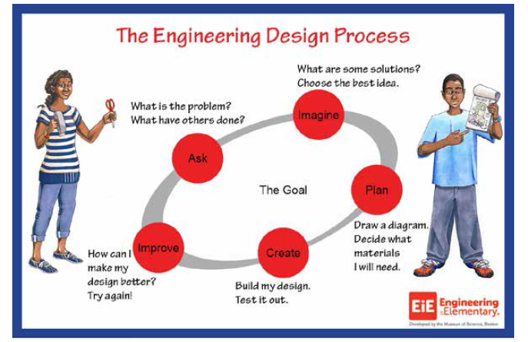

Activity
So we have a problem today that you need to solve.
This is Ted. He lives in a swamp. The swamp has lots of crocodiles. We need to build Ted a tower to keep him safe from the crocodiles.
The tower must be at least 25cm tall, because that’s how high the crocodiles can jump.
The only things you can use to build your tower are cards and masking tape. (You can use scissors to cut the card)
Get into groups (2, 3 or 4).
  - Top Tips before you begin
- Demonstrate how to rip masking tape with fingers
- Demonstrate how to roll, fold and cut cards
- Make sure you test your tower to see if it stands up by itself and can hold Ted
- You have …. minutes to complete this challenge. Time starts now!
Encourage students to test and improve their designs.
Demonstrate to groups how to use ruler (measuring from zero, pointing to 25cm mark on ruler)
Share all designs at end of session (if time permits) focussing on the problem-solving and improvements that students made to their tower designs.

