**Table 1 – Beyond Craft: STEAM and intentional play-based learning**

Mega blocks, musical instruments, puzzles – Latrobe City

Play-based activity related to theme – Casey Kardinia, Jenny

Screenless coding – Hobsons Bay, Jay

Maths & Science activity, alongside traditional craft – Geelong Regional

OSMO

Cardboard box creation after stories

STEAM Kits – backpacks on a theme (eg. Electricity) containing books, games & activities - Stonnington

Little Bang Discovery Club. Children’s Discovery Museum developed, Special session, homework (experiments), lots of carer involvement – Goldfields & Geelong

Themed STEAM activities related to story eg. sinking & floating, bugs, colours. Get inspiration from science books or own ideas – Monash

Puzzles & Dress-ups, floating activities – Bendigo & Boroondara

Lego Clubs, encourages story-making

Outdoor Storytime with games to follow eg. Skittles, quoits, very social – Wodonga

Incorporating science within a story – change up the songs, do a treasure hunt, playdough – Boroondara

Nonfiction to our Fiction. Talking about the real elements, guide to Dewey area - Boroondara

Musical Storytime. WISHLIST want to be able to incorporate more music, bands etc – Stonnington

Sorting rubbish for sustainability week – Goldfields

Bunnings will visit for free for a gardening session and will bring plants etc. Just ask your local Bunnings – Monash

Growing a seed on cotton wool

Suggestion – Men’s shed can come in to do an activity

Railway workers gave a Storytime when the local station was being worked on – Monash

Lollypop lady in May for Road Safety week – Monash

One branch has dress-ups and playdoh used once a term – Boroondara, Kat

Some do take home craft – Kingston

Some eliminated craft

Toddler sessions use bubbles

Time is the largest constraint

Developing new ideas, there is no time

Facilitation STEAM after sessions takes away from 1 on 1 time with children & carers

Would like packs or kits of pre-developed simple ideas – Little Bang Discovery group

Dramatic Arts – have kids work in groups to re-create scenes from books eg. Storm

**Table 2 – Family as first teacher: activating adult/child engagement**

Request that mobile phones are turned off and/or put away

Shared reading in toddler sets of books (30) or 15x30!!!$$$

Big Books – emphasis to parents to read/call/response

Lyrics on sheets

Song sheets to go home

Book of the month – read 4 times, book, puppets, props, kids, promote with poster – Monash, Wendy

Language barrier

Setting up the space, using semi-circle and bean bags, rug, chairs

Being welcoming to late comers

Activity with scissors to encourage parent supervision

Ask parents to join in

Multicultural ambassadors from the community to make the library more welcoming

Giving adults something to do in interactive components

Shared reading

Issues – language barriers, time needed to spend with families, adult literacy barriers

Modelling behaviour and getting children to vocalise instructions eg. “What do we want parents to do? Join in and have fun!”.

Song sheet are beneficial for adults who speak English as a second language.

Including multi language stories and songs, represents diversity of community and lets everyone join in.

Designing song sheets. Kanva online tool for visual design of resources

Ask families which songs they want to be included.

In Babytime emphasise the importance of the child hearing parents’ voices and role of parent as first teacher. Using books and reading together keeps engaged?? and lets children interact with book. If budget constraints propose buying a set and circulating them into collection after set time eg. 1 year.

Limiting session sizes to keep control and give more engagement for shared resources is one option. Other services encourage families to share books when groups are too big. Also gives adults who aren’t confident reading aloud to practice and do it at home.

How to promote borrowing of books after session?

* 1000 books before school
* It could be that some people don’t know borrowing is free, or that people are worried about fines etc.
* Forge connection and ask why they don’t borrow but frame it as a “How can we make our services or collection better for you?”
* Promoting fine-free libraries to remove barriers for patrons.

**Table 3 – Managing Disruptive Behaviour**

Rabbit? – only comes out if all children are ….

Let’s see if we can spot who is talking

Songs that have “sh-ing” at the end

Weekly introduction eg. Phones away for privacy reasons modelling for children.

Slide presentation behind us with request for silence. Especially good if you don’t feel comfortable with approaching/lecturing parents – Melton Libraries

Microphone allows you to speak quietly ad naturally which commands interest and is vey good for the voice – Monash Library, Lillian

Movement songs ending in sit down

Stretching followed by settling

Rain stick or shaker eggs

Stop and wait – be confident to try this

Silence sign - ???? lips

Sit down song

Teapot song, give tea to adult - YPRL

Any interactive song – Maribyrnong, Helen

No phones signage

Using humour

Listening ears on

Candle app/breathing

Switch to songs if losing crowd during the book

Giving tasks to obstructive children to get them involved

Social stories

Remind parents why we are all here – for the children

Housekeeping Rules:

* No photos
* Phones on silent
* Support me by not talking

Challenges:

* Being polite to parents
* Space
* Parents

A pair of children annoying each other:

* Mats for your own space
* Scarf to each child then locate them to different places eg. All red scarves sit here – can incorporate scarves into rhymes/songs eg. If you’re a red nod your head
* Give the children jobs eg. Every time you hear “The happy Prince” in the story, ring the bell.

Hocus Pocus time to Focus, Boroondara Libraries, Sharee Logan

You twiddle your thumbs, You clap your hands, And then you stamp your feet

You turn to the left, You turn to the right, You make your fingers meet,

You make a bridge, You make an arch, You give another clap,

You roll your hands, You wave your hands and put them in your lap (ready for the story)

**Table 4 – Beyond the printed word: alternative Storytelling techniques**

CD story using actions. Audio book, short, play act the story. No word book or screen images, discuss with children and create a story about what is happening – Lisa Stebbing [lisasteb@hotmail.com](mailto:lisasteb@hotmail.com)

Felt boards for each child – Brimbank Libraries, Helen Doherty

Puppets, how to use training. ??? Dorrett or other presenter

Oral story kits (better for smaller groups) – Goldfields, Ange

How do you incorporate alternate storytelling with large groups? Mr Squiggle style

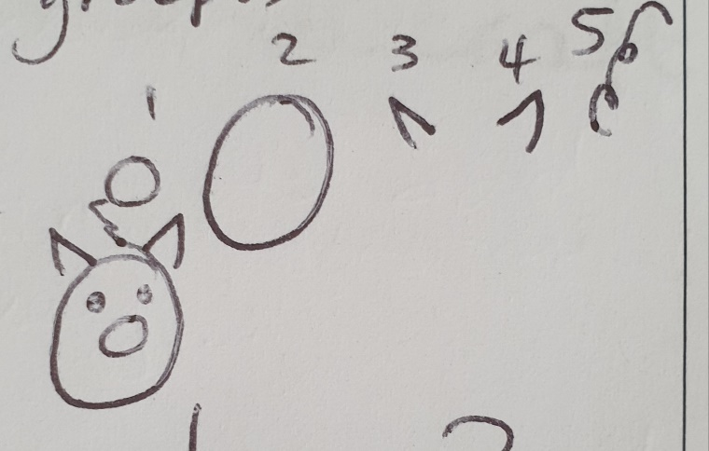

Where is the green sheep? Lots of sheep puppets hidden around the library – Drouin Library, Michelle

Animals in a bucket

We need more money & time

Magic hat – wear the hat and pass it round while reading the story

Wombat Stew – cauldron children put items in the cauldron

Collect items from Op Shops

Song Sheets

Start of session encourage parents to join in

Reading story, stop, let parents and children finish the line

Use puppets

AUSLAN story telling and to learn animal words

Incorporate ‘Boy’ into Storytime session

VIC Deaf great website to use

Using wordless picture books eg. 600 black dots, pop-up book to discuss basic art? concepts.

Wordless books help kids to create their own stories

Use old books to create felt stories or use magnetic buttons

Foot stories – at night using your feet to act out the stories – learnt from Tanya Batt NZ librarian

Using props to embellish a story

Using screenless coding in the sessions – instead of screens use boxes

Alternate story telling techniques currently used:

* Felt Boards
* Hand telling Storytime – JBrary Storytelling
* Add AUSLAN elements
* Act out songs wearing costumes eg. Bakers Hat
* Discuss the story of the song
* Skill Gaps – for alternative story telling

Skill Gaps - Time consuming with on desk tasks

**Table 5 – Supporting vulnerable families: ParentsNext, recently arrived migrants, CALD communities, etc.**

Collecting books in different languages – familiar stories

Singing songs in different languages

Maternal Child Health Nurse visits

Smith Family

Interpreter services

Child Safe

It’s not our role to ‘sign’, ‘sight’, ‘keep track’. We can’t encourage the fear. We are not gatekeepers libraries for all.

Take photo of book, library receipt, craft

We aim to give a positive experience – welcome, fun, inclusive.

ALIA – parents next for their statement

Making the space fun eg. Supervised visits with blocks etc.

New York Library lends out modems, access for internet

Vulnerable youth – Baseline & youth services. Wireless charging devices or loan out the cords – Monash Library

Toilets are an asset (& showers) ?? evacuation centre Whittlesea

Intergenerational Storytime with nursing homes – YPRL, Coralie

Opportunity to make safe space connections:

* Family worker from council who attends Storytime – Port Philip, YPRL (community connections)
* Brotherhood of St Laurence
* Neighbourhood House
* Maternal health nurses, cross promotion for visits & vaccinations, important for new migrants – Monash
* Northern Health Pop-Up Library at hospital, take a wifi hotspot

Existing programs:

* Homework help at housing estates work in partnership with family life
* Opportunities to work within community hubs to provide assistance.

How to approach people or give info about services available?

Teens – giving info displaying pamphlets for services in the teen area eg. Headspace, which allows them to discretely take them.

It is important to stay within our boundaries of what we are trained to provide.

Sensitive Storytime – making all sessions inclusive rather than holding specific/separate sessions, and making connections with groups in the community so they know they are inclusive.

CALD and newly arrived migrants. Multilingual Storytime beneficial for both parents & children, but really focused on children.

Getting CALD communities to come into the library:

* Found that outreach visits are well received but don’t see migrants of certain communities coming into the library. A cultural barrier that is difficult to overcome.
* If adults don’t speak English they may not think there is anything at the library for them. Also, possible that we are seen as government /authority and could be feared. Some cultures may also believe that children shouldn’t be read to until they are at school age, and they won’t come to the library.

Faulkner Library: word play in collaboration with M??? Health:

* A program to help parents with English, with ocus on newly arrived migrants, but open to all. But it was difficult to meet goal of reaching new migrants. Feedback of child confidence and other positive feedback but found that majority of attendees were the same as who were coming to other programs. Would be beneficial if it was part of a referral program.

FIELS program: homework help where parents come too – Maribyrnong Council run but supported by the library.

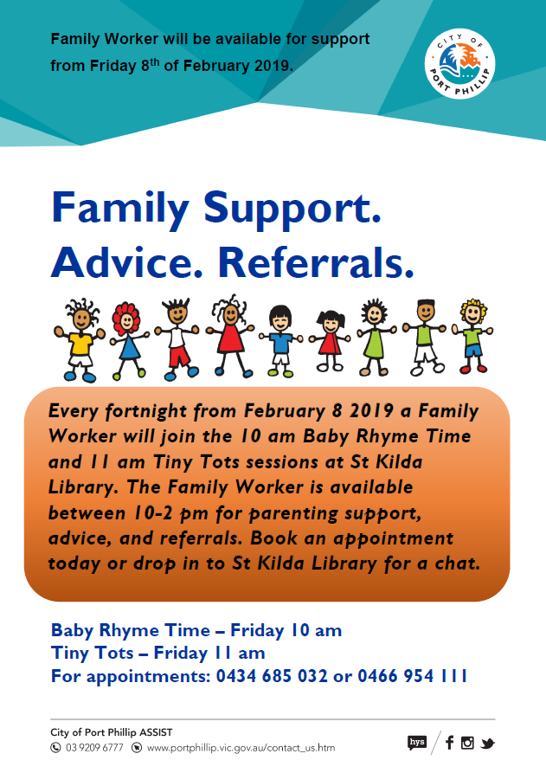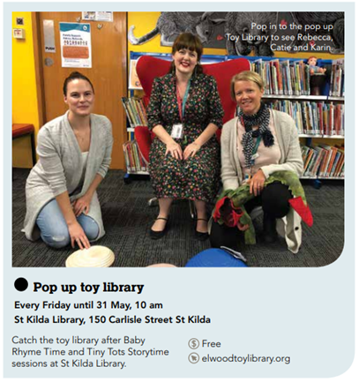

**Table 6: Readers Advisory: selecting books, recommending titles, promotion of collections.**

Aboriginal Language. Board, App, Collections – [juliec@wgrlc.vic.gov.au](mailto:juliec@wgrlc.vic.gov.au)

Summer Reading Club Aboriginal

1000 Books Before School *Effective* means of encouraging reading

Activities – holiday program – making robots/display robot books

Dr Seuss Day – display Dr Seuss books

Story boards – books

Website/Social Media/Branch

Displays x 2

Target themes – special days & events

Reviews of books and display of reviews

Suggestion Box to purchase items

Craft tables - crafts reflect special days/themes

Activity box – online Busy Things

Safe Apps

Access to iPads for public

Readers Advisory bookmarks – go out of date quickly

Catalogue displays – orated recommendations on Spydus & auto generated new titles

Marketing on Facebook – videos featuring themed displays/resources. Resources on Facebook with description of reviews.

In person – find out what child enjoys and recommend similar books

??? topic booklists, online or staff generated, Goodreads for recs, Common Sense Media

e-newsletters from publishers, book shops, buzz feed ect.

Felt board or A-frame themed to promote event, special day.

Book of the Week – personalised with a picture of the librarian.

How to choose for Storytime – themes, with craft ideas or literacy prompts, classics, favourites.

Use Storybox Library, modifying for different ages.

Visit other Storytimes.

How to get people to borrow after a session:

* Bribe to borrow – every 5 books gets a sticker or token/stamp
* Have books ready to borrow, books on the floor.

In branch – displays:

* Promotion of new items during children’s programs/events
* Items related to topic of program/event